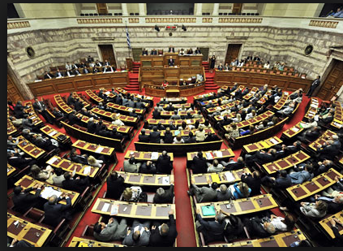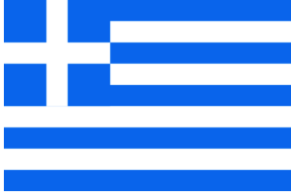

**5 Political Parties**

**The PanHellenic Socialist Movement**- Founded in 1974 as a radical party has evolved into a social democratic party. It is also one of the two leading political parties in Greece.

**New Democracy-** Founded in 1974 is a Liberal Conservative political party. It is one of the two major political parties in Greece. It holds the current Prime Minister Antonis Samaras.

**Communist Party of Greece**- Is a socialist party founded in 1918. It is the oldest political party in Greece.

**Coalition of the Radical Left**- A party formed of left wing and radical left parties.

**Popular Orthodox Rally**- Is a radical right-wing populist party. Founded in 2000.

**President**

The formal name is the President of the Hellenic Republic. The president is elected by parliament for a term of 5 years. The role of the president is mostly ceremonial, not much power comes with this title.

**Prime Minister**

The formal name is Prime Minister of the Hellenic Republic. This is the role that contains the most power; it is the head of government. Parliament elects the Prime Minister.

**Parliament**

Consist on 300 members of supreme democratic personnel that represent the citizens of Greece. It also consists of 5 political parties. To become a member you must receive 3% of the population’s votes.

**Court System**

There are two branches of the Judicial System.

**Court of Cassation**- This is the Supreme Court for civil and criminal law.

**Council of State**- This is the Supreme Administrative Court. The President heads this branch.

##### Greece did not become an independent country until 1829, after the War of Independence ended. Then in 1952 Greece decided to join with other western democracies and become a member of NATO. This meant that they started to embrace other democratic values. For many years Greece had multiple rulers that failed and were removed from power. In 1975 the New Democracy Party created the Greek Presidency. Since the 2000 elections the economy has improved drastically due to Prime Minister Constantine Simitis’s leadership.

# Structure of Greek Government